1. **INTRODUCTION**

The project titled Library Management System is Library management software for monitoring and controlling the transactions in a library.The project “Library Management System” is developed in Pyhton , which mainly focused on basic operations in a library like adding new member,new member,new books,and updating new information,searching books and facility to borrow and return book.

“Library Management Notification System” is a windows application written for 32-bit windows operating systems,designed to help users maintain and organize library.our software is easy to use for both beginners and advanced users.it features a familiar and well thought-out an attractive user interface,combined with strong searching insertion and reporting capabilities.The report generation facility of library system helps to get a good idea of which are the books borrowed by the members,makes users possible to generate report’s hard copy.

The software Library Management Notification System has four main modules

* Insertion to Database Module-user friendly input screen.
* Extracting from Database module-Attractive output screen.
* Report Generation module-borrowed book list&Available book list.
* Search Facility system-search for books and members.

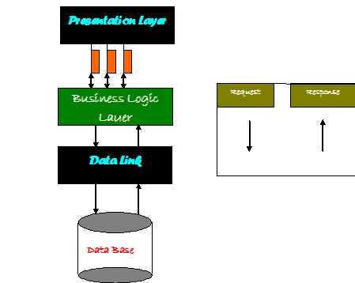

**Figure 1: WORK FLOW DIAGRAM**